SCHOOL OF COMPUTER SCIENCE AND ARTIFICIAL INTELLIGENCE |  |  |  |  | DEPARTMENT OF COMPUTER SCIENCE ENGINEERING
Program Name: B. Tech |  |  |  | Assignment Type: Lab |  |  | Academic Year:2025-2026
Course Coordinator Name |  |  |  | Venkataramana Veeramsetty
Instructor(s) Name |  |  |  | Dr. V. Venkataramana (Co-ordinator)  Dr. T. Sampath Kumar  Dr. Pramoda Patro  Dr. Brij Kishor Tiwari  Dr.J.Ravichander  Dr. Mohammand Ali Shaik  Dr. Anirodh Kumar  Mr. S.Naresh Kumar  Dr. RAJESH VELPULA  Mr. Kundhan Kumar  Ms. Ch.Rajitha  Mr. M Prakash  Mr. B.Raju  Intern 1 (Dharma teja)  Intern 2 (Sai Prasad)  Intern 3 (Sowmya)  NS_2 ( Mounika)
Course Code |  |  | 24CS002PC215 | Course Title |  | AI Assisted Coding
Year/Sem |  |  | II/III | Regulation |  | R24
Date and Day  of Assignment |  |  | Week3 – Monday | Time(s)
Duration |  |  | 2 Hours | Applicable to  Batches
Assignment Number:6.1(Present assignment number)/24(Total number of assignments)
 | Q.No. | Question |  |  |  |  |  | Expected Time  to complete
 | 1 | Lab 6: AI-Based Code Completion – Classes, Loops, and Conditionals  Lab Objectives:  - To explore AI-powered auto-completion features for core Python constructs.  - To analyze how AI suggests logic for class definitions, loops, and conditionals.  - To evaluate the completeness and correctness of code generated by AI assistants.  Lab Outcomes (LOs):  After completing this lab, students will be able to:  - Use AI tools to generate and complete class definitions and methods.  - Understand and assess AI-suggested loops for iterative tasks.  - Generate conditional statements through prompt-driven suggestions.  - Critically evaluate AI-assisted code for correctness and clarity.  Task Description #1 (Classes – Employee Management)  - Task: Use AI to create an Employee class with attributes (name, id, salary) and a method to calculate yearly salary.  - Instructions:  - Prompt AI to generate the Employee class.  - Analyze the generated code for correctness and structure.  - Ask AI to add a method to give a bonus and recalculate salary.  Expected Output #1:  - A class with constructor, display_details(), and calculate_bonus() methods.  Task Description #2 (Loops – Automorphic Numbers in a Range)  - Task: Prompt AI to generate a function that displays all Automorphic numbers between 1 and 1000 using a for loop.  - Instructions:  - Get AI-generated code to list Automorphic numbers using a for loop.  - Analyze the correctness and efficiency of the generated logic.  - Ask AI to regenerate using a while loop and compare both implementations.  Expected Output #2:  - Correct implementation that lists Automorphic numbers using both loop types, with explanation.  Task Description #3 (Conditional Statements – Online Shopping Feedback Classification)  - Task: Ask AI to write nested if-elif-else conditions to classify online shopping feedback as Positive, Neutral, or Negative based on a numerical rating (1–5).  - Instructions:  - Generate initial code using nested if-elif-else.  - Analyze correctness and readability.  - Ask AI to rewrite using dictionary-based or match-case structure.  Expected Output #3:  - Feedback classification function with explanation and an alternative approach.  Task Description #4 (Loops – Prime Numbers in a Range)  - Task: Generate a function using AI that displays all prime numbers within a user-specified range (e.g., 1 to 500).  - Instructions:  - Get AI-generated code to list all primes using a for loop.  - Analyze the correctness and efficiency of the prime-checking logic.  - Ask AI to regenerate an optimized version (e.g., using the square root method).  Expected Output #4:  - Python program that lists all prime numbers within a given range, with an optimized version and explanation.  Task Description #5 (Classes – Library System)  - Task: Use AI to build a Library class with methods to add_book(), issue_book(), and display_books().  - Instructions:  - Generate Library class code using AI.  - Analyze if methods handle edge cases (e.g., issuing unavailable books).  - Ask AI to add comments and documentation.  Expected Output #5:  - Library class with all methods, inline comments, and explanation.  Note: Report should be submitted a word document for all tasks in a single document with prompts, comments & code explanation, and output and if required, screenshots  Evaluation Criteria:  Criteria Max Marks  Class 1.0  Loops 1.0  Conditional Statements 0.5  Total 2.5 Marks |  |  |  |  |  | Week3 - Monday

ROLLNO:2403A510f8
#TASK1
PROMPT: write a python class employee management having attributes name,id,salary and add a method that calculate yearly salary ,other method bonus that calculate bonus and recalculates salary ,display yearly salary and yearly salary after bonus.
CODE:
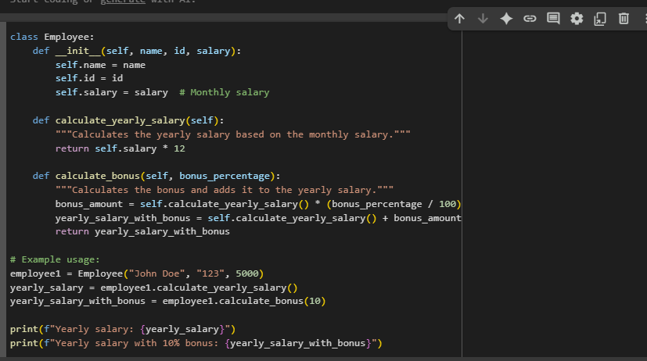
OUTPUT:

OBSERVATION: The code defines an Employee class with attributes: name, id, and salary.
- calculate_yearly_salary() – computes yearly salary from the monthly salary.
- calculate_bonus(bonus_percentage) – calculates and adds a bonus percentage to the yearly salary.

#TASK2:
PROMPT: WRITE A PYTHON FUNCTION THAT CALCULATES AUTOMORPHIC NUMBERS IN RANGE 1 TO 1000 USING FOR LOOP ,DISPLAY THE LIST OF AUTOMORPHIC NUMBERS IN RANGE.
CODE:(USING FOR LOOP)
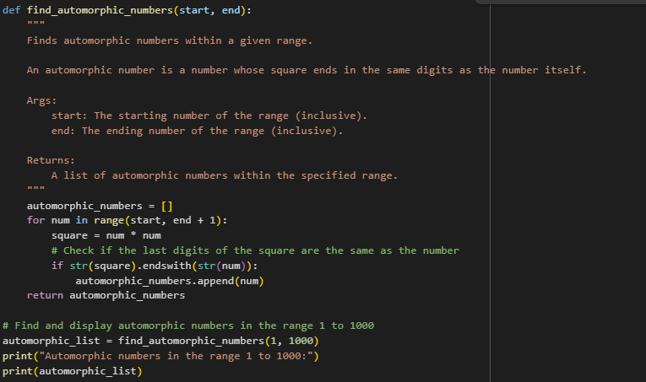
OUT PUT:
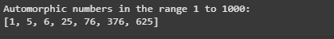
CODE:(USING WHILE LOOP)
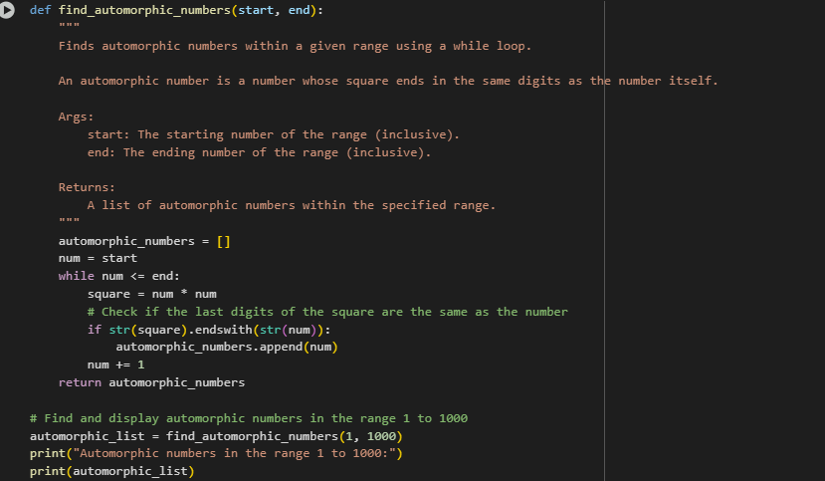
OUTPUT:
OBSERVATION: The program correctly identifies automorphic numbers in the range 1 to 1000 using both for loop and while loop.
The result [1, 5, 6, 25, 76, 376, 625] is consistent in both methods, proving the logic works for different looping constructs.

#TASK3:
PROMPT: You are tasked with writing a Python program to classify online shopping feedback based on a numerical rating (1–5).
- First, write code using nested if-elif-else conditions to classify ratings:
  - 4 or 5 → "Positive"
  - 3 → "Neutral"
  - 1 or 2 → "Negative"
- Analyze your code for correctness and readability.
- Rewrite the solution using either a dictionary-based approach or a match-case structure (Python 3.10+).
- Display example outputs for different inputs (e.g., 1, 3, 5).
CODE:(USING DICTIONARY)
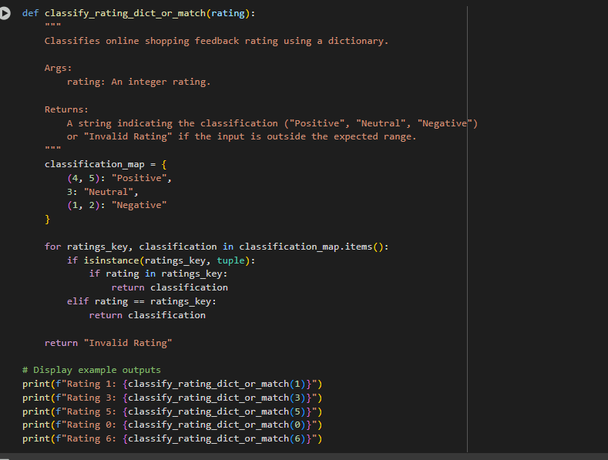
OUT PUT:(NESTED IF-ELSE/MATCH-CASE APPROCH..)

CODE:
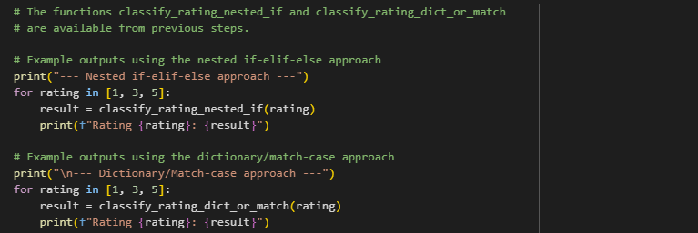

OUTPUT:
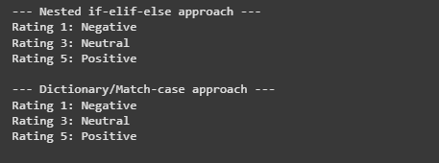
OBSERVATION: The program correctly classifies online shopping feedback using nested if-elif-else conditions.
It was later rewritten using dictionary/match-case for improved readability and maintainability.
Both approaches give accurate results, demonstrating different conditional constructs in Python.

#TASK4:
PROMPT: Write a Python function that displays all prime numbers within a user-specified range (for example, 1 to 500).
- First, generate code using a for loop to check and list prime numbers in the range.
- Analyze the correctness and efficiency of the prime-checking logic.
- Then, regenerate an optimized version of the function using the square root method for prime checking.
- Show example outputs for a range such as 1 to 50.
CODE:
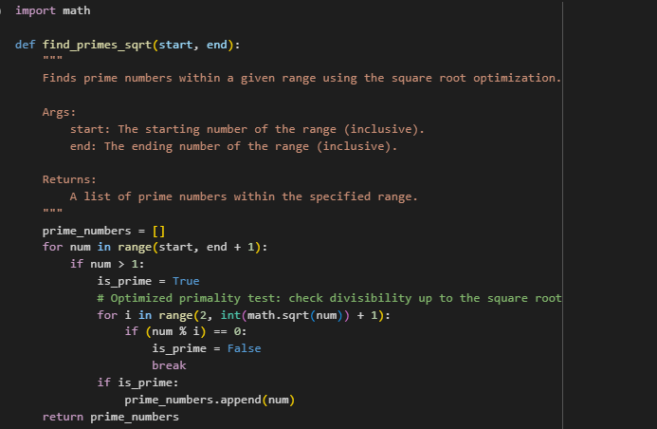
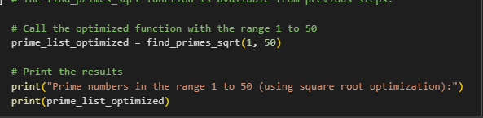
OUTPUT:
OBSERVATION: The program successfully generates prime numbers in a given range using a for loop.
The optimized version with the square root method improves efficiency by reducing unnecessary checks.
This demonstrates the use of loops, conditional statements, and optimization techniques in Python.

#TASK5:
PROMPT: Write a Python program that defines a Library class with the following methods:
- add_book(title) → to add a new book to the library collection.
- issue_book(title) → to issue a book if available, otherwise show an appropriate message.
- display_books() → to display the list of available books.
CODE:
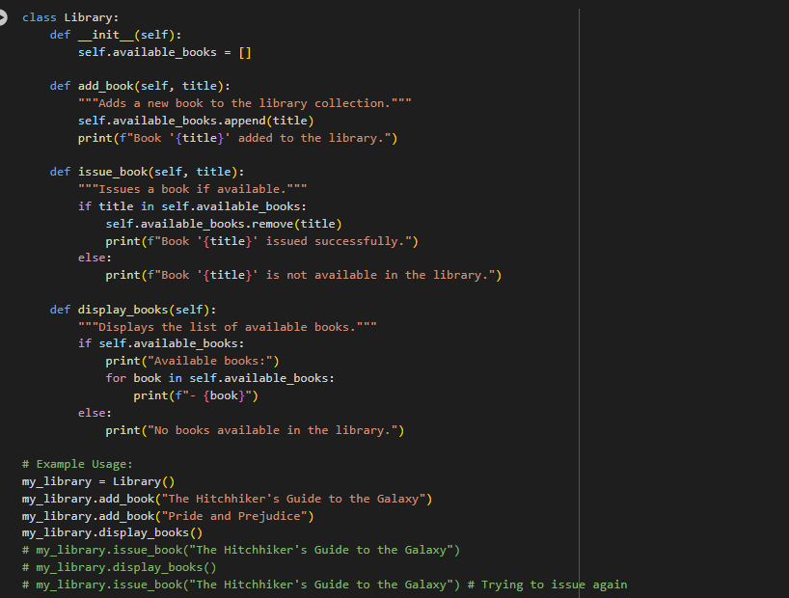
OUT PUT:


OBSERVATION: The Library class effectively demonstrates object-oriented programming concepts such as class, methods, and encapsulation.
Edge cases like issuing unavailable books are properly handled with informative messages.

